My Life as a Foreign Country
Part 1
Scene selected from Section 3 pg. 14
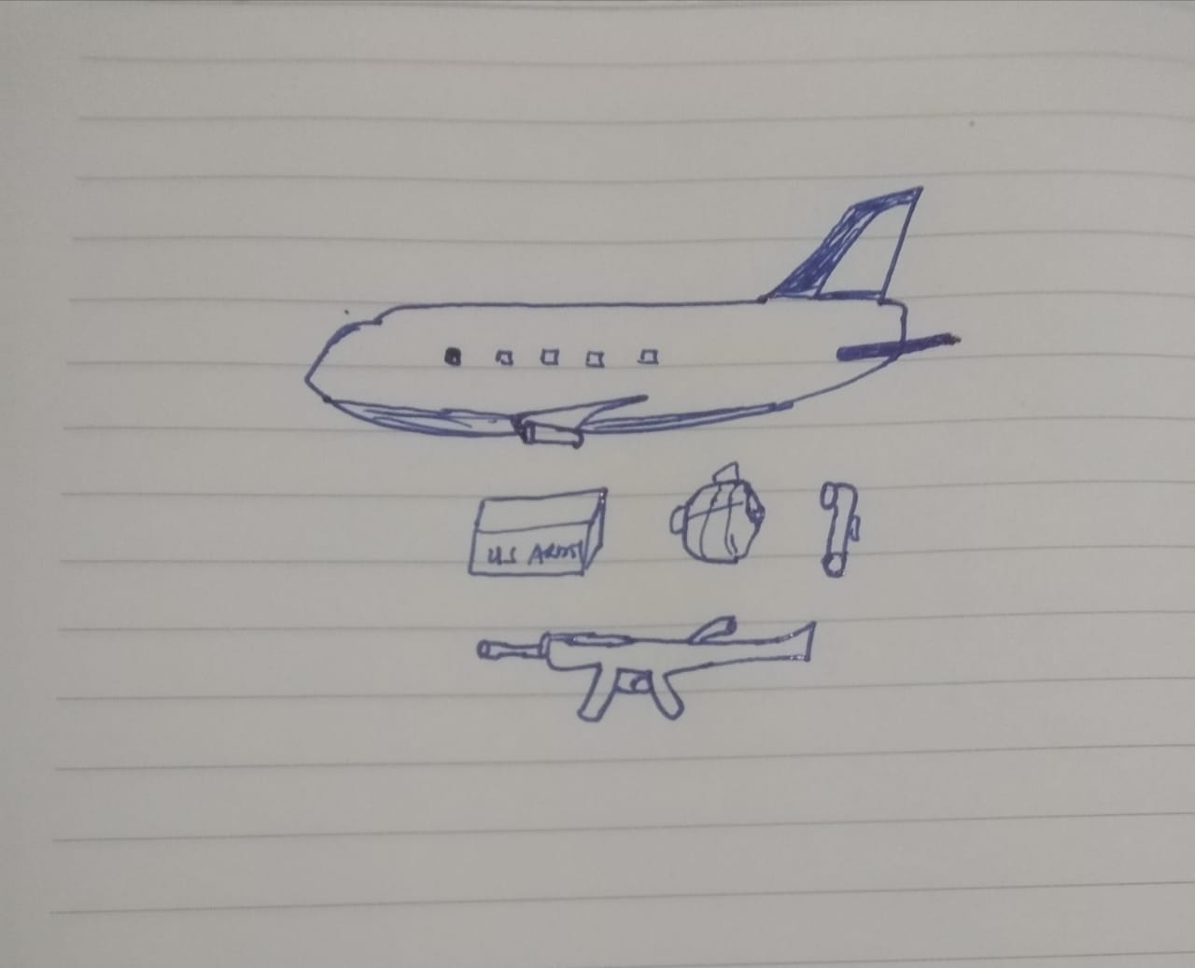
In this scene, Turner describes how they have received plenty of supply from the government. He also describes how the equipment they are provided are new and expensive. This scene catch my attention because as turner explain, journalists were airing stories to the effect that units were lacking proper gear like the body armor. It indicates how sometimes news may not be accurate in reporting the situation on the ground.
Part 2
The interview by Turner, the author of this memoir is quite insightful in as it provides an opportunity to understand what was happening in his head. First he states on the reason why he decided to write and secondly he also explains his style of writing where he tries to create a clear picture to the readers by use of pictures.
The interview add to my understanding of the book in the sense that Turner endeavor to bring out the situation on the ground and what transpires there in the most realistic manner. In trying to achieve this, he try to deconstruct the misconceptions and misrepresentations of what the people believe happens from either the narration of from watching the media. In the book he highlights several scenarios where the media have misrepresented facts like the instance where they were saying that there is lack of supply. Another example is where he watches video being displayed on the television about the fight between the US soldiers and Iraqis in a bridge (Turner, 2014), this video is being narrated by a news anchor and happens in section 2. He calls it out.
During the interview, one of the reasons he gives for writing the book is to represent what transpired during the combat. He explains that he was writing every detail of occurrences in a diary which he kept to ensure that he does not forget. His account therefore gives the most accurate experience of living in warring countries, the constant stress that comes with living without knowing your fate the next day and the manner in which soldiers cope with this stress.
Reading through the book has helped me discard all the notions which I held about the fight in Iraq, Iran, Afghanistan and other countries where our troops have been deployed. Their courage and sacrifice and helped have a feel of what living a life as a foreign country really is.

References
Turner, B. (2014). My Life as a Foreign Country: A Memoir. WW Norton & Company.

